The Great Outdoors Challenge
Vetters' Database
Management Plan

Prepared by: Mick Blackburn - Consultant

CHANGE RECORD

Rev | Status | Date | Comments
0.1 | Draft |  | Issued for review by the TGOC Coordinators
0.3 | Draft | 31 Jul 2020 | Issued for review by the TGOC Coordinators

distribution
Name | Location
Ali Ogden & Sue Oxley | TGOC Coordinators

Contents

1. Introduction 8
1.1 Document Overview 8
1.2 TGOC Document Suite Hierarchy 8
1.3 Scope 8
1.4 Names of Position Holders 8
1.5 VDMP Document Review and Update 9
2. Referenced Documents 10
3. TGOC Event Overview 11
3.1 The Event 11
3.1.1 Start and End Points 11
3.1.2 Route Planning 11
3.2 Route Vetting 11
3.3 Challenge Control 11
3.4 Event Safety and Risk 12
3.5 Management 12
4. Key Personnel: Vetters’ Database Roles and Responsibilities 13
4.1 Chain of Command 13
4.2 Kelsey Media 13
4.3 TGOC Coordinator(s) 13
4.4 TGOC Route Vetters 13
4.5 TGOC Control Volunteers 13
4.6 TGOC Challengers 13
5. The Vetters’ Database 14
5.1 Purpose 14
5.2 Database Operational Requirements 14
5.3 Proposed Database Solution 14
5.4 Database User Guide 14
5.5 Database Build Guide 15
6. Management of the Vetters’ Database 16
6.1 Configuration Control 16
6.2 Fault Reporting 16
6.3 Maintenance of the Database 16
6.3.1 Item and Type Definitions 16
6.3.2 Data Update 16
6.3.3 Additional Items 17
6.3.4 Additional Types 17
6.4 Accessing the Vetters’ Database Files 17
7. Definitions and Acronyms 18
7.1 Definitions 18
7.2 Acronyms 19
APPENDIX A – Using the Vetters’ Database 21
1. Accessing the Vetters’ Database 22
1.1 File Options 22
1.2 Opening, editing and saving the Excel file 24
2. Vetters’ Database Map Display 25
2.1 Leaflet Functions 25
2.1.1 Changing the Map Scale 25
2.1.2 Map Scale and Centre Position 25
2.1.3 Map and Track Selection 26
2.1.4 List (Folder) of Icons by Type and Name 27
2.1.5 Decluttering the Map 28
2.1.6 Moving, Collapsing and Expanding Boxes 28
2.1.7 Panning the Map 28
2.2 Vetters’ Database Icon Meaning 28
2.3 Icon Interaction 29
2.4 Other Function 29
APPENDIX B – Building the Vetters’ Database 30
1. Introduction 31
2. Data Collection Formats 32
2.1 MS Excel Spreadsheet 32
2.1.1 Worksheet 1 - Data Input 32
2.1.2 Worksheet 2 - GPSV Format 34
2.1.3 Worksheet 3 - Degrees to Dec Converter 34
2.1.4 Worksheet 4 - Look-Up Tables 35
2.2 GPX Files 37
2.3 Picture Files 37
2.3.1 Thumbnail Pictures 37
2.3.2 Photographs 38
2.3.3 Acquiring the picture URL 38
2.3.4 Storing the URL(s) in the Spreadsheet 38
3. GPS Visualizer Data Input 39
3.1 General Map parameters 40
3.2 Track Options 42
3.3 Waypoint Options 43
3.4 Upload your GPS data files here:? 44
3.5 Or paste your data here:? 44
3.5.1 Saving a spreadsheet as a CSV file ready for use 45
3.5.2 Opening a CSV file in MS Word 45
3.5.3 Copying the CSV data 46
3.5.4 Pasting the CSV data into the GPSVisualizer From 46
3.6 Saving and Loading GPSV Settings 46
3.6.1 Saving the Settings for the GPSV Input Form 47
3.6.2 Loading the pre-saved Settings into the GPSV Form 47
4. Generating and sharing the map 48
4.1 Build Preparation 48
4.2 Generating the Map 48
4.3 View/Download Options 49
4.3.1 View 49
4.3.2 Download 49
APPENDIX C – New Type/Item Data Required 51
1. Introduction 52
1.1 New Type 52
1.2 New Item 52

TABLE OF FIGURES
Figure 1: Document Suite & Hierarchy 8
Figure 2: TGOC Chain of Command 13
Figure 3: Descriptions of Capitalized Terms 18
Figure 4: Acronyms 19
Figure 5: Newtonmore Hostel - Vetters' Database page 22
Figure 6: XLS Button 22
Figure 7: XLS Message Box 23
Figure 8: Enable Editing button 23
Figure 9: Download Arrow and Message 23
Figure 10: Download File Directory 24
Figure 11: Vetters’ Database Display 25
Figure 12: Scale Slider Bar 25
Figure 13: Map Scale and Centre 26
Figure 14: Map and Track Selection 26
Figure 15: List (Folder) of icons by Type 27
Figure 16: Expanded Folder 27
Figure 17: Icon details 28
Figure 18: Icon text box 29
Figure 19: Data Input Header Fields 33
Figure 20: Degrees to Dec Converter 34
Figure 21: Worksheet 4 - Symbols Table 36
Figure 22: Colour Options 37
Figure 23: Vetters’ Database GPSV Format 38
Figure 24: GPSV Format Options 39
Figure 25: GPSV Leaflet Form 39
Figure 26: General Map parameters 40
Figure 27: General map parameters – expanded 40
Figure 28: Track options 42
Figure 29: Track Options – expanded 42
Figure 30: Waypoint options 43
Figure 31: Expanded 'Waypoint options' 43
Figure 32: GPS data files upload 44
Figure 33: CSV Data Input 44
Figure 34: File In Use 45
Figure 35: CSV File in Word 46
Figure 36: Completed CSV Data Box 46
Figure 37: Saving and Loading Settings 47
Figure 38: Generating the map 48
Figure 39: Leaflet Map output 49
Figure 40: Download Dialogue Box 49
Figure 41: Item Data required 52

Introduction

Document Overview
This Vetters’ Database Management Plan (VDMP) for The Great Outdoors Challenge (TGOC) forms part of the overall document suite (Figure 1: Document Suite & Hierarchy). In addition to descriptions of the TGOC, its organisation, management and the various stakeholders, this document contains a description of the Vetters’ Database, how it is managed, used, built and maintained.

TGOC Document Suite Hierarchy
The TGOC document suite, together with its hierarchy, is as follows:

Event Management Plan
Vetters’ Database Management Plan
Safety Management Plan
Risk Management Plan
Risk
Register
Vetters’ Database
Safety Procedures & Protocols
TGOC Contact List

Figure 1: Document Suite & Hierarchy

Scope
The scope of this document is to define how the Coordinator(s) and the Vetters, as part of the Event management activities, will implement and maintain the TGOC Vetters’ Database Management elements. In addition, the instructions for use and the instructions for building the database are included as appendices. It should be noted that this document deals with the operation of the database map, not with the associated MS Excel spreadsheet, as it is assumed that the users are familiar with the operation of spreadsheets.

The Vetters’ Database itself (i.e. the map-based display produced using the online website GPSVisualizer), the associated MS Excel file(s) and this document have been produced by the author with assistance from the TGO Coordinators and Vetters.

Names of Position Holders
The names of personnel holding significant positions within the management of the Event are held in The TGOC Contact List [Ref. 4].

VDMP Document Review and Update
The VDMP shall be reviewed on an annual basis by the Coordinator(s) and the document updated to take account of the review. The updated document shall then be issued as defined in the Event Management Plan (EMP) [Ref. 1].

Referenced Documents
Ref. No. | Title
1 | Event Management Plan
2 | Safety Management Plan
3 | Risk Management Plan
4 | TGOC Contact List

TGOC Event Overview
This section provides an overview of the Event; for a full description see the EMP [Ref. 1].

The Event
The TGOC Event is a self-supported, Scottish Coast-to-Coast backpacking adventure that is owned by Kelsey Media and organised by the TGOC Coordinators. It takes place in May of each year and is nominally 2 weeks in duration. Prospective participants (Challengers) complete an online application form for a place on the Event and if successful in their application, devise their own routes to traverse Scotland. Challengers can hike solo or in a team (up to maximum of 4 Challengers per team). Each Challenger must submit a medical declaration and provide a point of contact in case of emergencies as part of the TGOC application process. It should be noted that the TGOC is for experienced backpackers: it is not aimed at inexperienced backpackers or beginners.

Start and End Points
Challengers must begin from one the nominated sign-in points (see EMP [Ref. 1] for details) on the west coast of Scotland and walk across Scotland to finish on the east coast anywhere between Arbroath in the south, to Fraserburgh in the north. The Event geographical boundaries are defined in the EMP [Ref. 1]. Once their walk is completed, Challengers must make their way to Montrose to sign out at TGOC Control located in the Park Hotel, Montrose.

Route Planning
Each Challenger must submit their planned route, by completing the on-line TGOC Route Sheet, to the Coordinators for vetting and approval.

Route Vetting
Route vetting is conducted by members of the TGOC Vetting Team: individuals selected for their extensive knowledge and experience of the terrain, conditions, environment and difficulties that may be encountered by Challengers during the event.

The vetting process examines the submitted route to ensure accuracy and coherence; it also takes into account the experience level as declared by the Challenger. The feedback given to the Challenger, via the Coordinators, provides advice and guidance on the route submitted.

For a Challenger to start the Event, their Route Sheet must have been formally approved by the Coordinators.

Challenge Control
TGOC Control, located in the Park Hotel in Montrose, is manned for the duration of the TGOC Event. TGOC Control provides the following for Challengers:
- a safety check-in point;
- advice and support;
- the provision of weather forecasts; and
- a callout of emergency services if required.

Event Safety and Risk

Management
Event Safety and Risk Management is taken extremely seriously by all those involved: Kelsey Media, Coordinators, Vetters, Volunteers and Challengers; moreover, it is considered at every stage of the Event Lifecycle, with specific measures, processes, procedures and protocols.

For a detailed explanation see the Safety Management Pan (SMP) [2] and the Risk Management Plan (RMP [3]).

Key Personnel: Vetters’ Database Roles and Responsibilities
This section details of the chain of command of key personnel, and an outline of their roles and responsibilities for the management of the Vetters’ Database.

Chain of Command

Kelsey Media
MD

TGOC Coordinators
TGOC
Vetters
TGOC
Challengers
TGOC
Volunteers

Figure 2: TGOC Chain of Command

Kelsey Media
Kelsey Media is the owner of the TGOC Event.

TGOC Coordinator(s)
Coordinators are contracted by Kelsey Media to act as the organisers of the Event. In addition, they have the following Vetters’ Database responsibilities to:
- review and update the VDMP, annually;
- manage the Vetters’ Database in accordance this VDMP;
- verify, where possible, new items that are to be entered into the database;
- update the Vetters’ Database as and when new items need to be included; and
- maintain the configuration control of the Vetters’ Database to ensure that Vetters are aware of, and are using, the latest issue.

TGOC Route Vetters
Route Vetters are unpaid Volunteers who conduct a review of the Route Sheets as submitted by Challengers. The Vetters have the following Vetters’ Database responsibilities to:
- assist the Coordinator(s) in the capture of any new items to be included in the database; and
- report any faults, errors or changes required to the status of items in the database to the Coordinator(s).

TGOC Control Volunteers
The Vetters’ Database is not issued to the TGOC Control Volunteers.

TGOC Challengers
The Vetters’ Database is not issued to the TGOC Challengers.

The Vetters’ Database

Purpose
During the process of Route Vetting, Challengers are often advised of difficulties that may arise on the submitted route, based upon the Vetters’ experiences in the field, which are not always evident from the available mapping. These may be obstacles or points of interest such as:
- Event start/end points;
- bridges that are damaged, missing or newly installed;
- new fences (possibly electrified) that may cause route issues;
- access issues;
- difficult ground;
- estate requests (the TGOC receives requests from Scottish estates asking that Challengers avoid, take specific routes through or do not camp in certain areas); and
- where Foul Weather Alternatives (FWA) routes are mandatory/advised.

The concept and purpose of the Vetters’ Database is, therefore, to provide a shared, central, collective body of knowledge taken from the Vetter’s experiences for the use of the Vetting Team, and thus to ensure consistency of advice.

Database Operational Requirements
The idea of a central database, where the Vetters provide inputs based on their experiences, was initially proposed by the Coordinators with the broad, operational requirements that it is:
- relatively easy to manage, use and update;
- freely available;
- map-based (preferably a no-cost mapping application);
- provided with a spreadsheet-based option (for easy filtering/searching); and
- capable of displaying, at a minimum, those items listed in section 5.1.

Proposed Database Solution
The proposed solution to the above requirements is the use of a free, online mapping website called GPSVisualizer (www.gpsvisualizer.com), which is fairly simple to use and update. This application allows the data to be input in several ways including spreadsheet data, and gpx files as may be produced by commonly used route mapping software such as Anquet and Memory Map.

GPSVisualizer overlays these data (spreadsheet and mapping) onto an interactive map image for display and use. The maps used by the Vetters’ Database are from a freely available (open source), online, mapping system called Leaflet (very much like Google maps, but without the access restrictions of Google maps).

In addition, GPSVisualizer allows photographs to be displayed as part of the data overlay, which is achieved by the inclusion of ‘pointers’ to the photographs (in the form of URLs) within the spreadsheet. It is proposed that the electronic photographs for the Vetters’ Database are held within the Newtonmore Hostel website (owned by the Coordinators), which will allow them to be access-controlled, available and maintainable.

Database User Guide
The User guide for the Vetters’ Database is at APPENDIX A – Using the Vetters’ Database.

Database Build Guide
The Data Build Guide for the Vetters’ Database is at APPENDIX B – Building the Vetters’ Database.

Management of the Vetters’ Database
The main issues for the management of the Vetters’ Database are to ensure that:
- Vetters have access to the latest, consistent data; and
- Errors/corrections within the database can be identified and corrected.

The following sub-sections define how these issues will be addressed.

Configuration Control
The Coordinators are responsible for the configuration control of the Vetters’ Database, i.e. ensuring that the different versions (as they become available) are separately identified by using an appropriate file naming convention e.g. ‘Vetters Database Vsn 1’, ‘Vetters Database Vsn 2’, etc. This will allow the users to identify which version they are using, thus ensuring that it is the most recently available.

Fault Reporting
It is likely that there will be faults discovered in the various iterations of the Vetters’ Database either in the production of the mapping system (e.g. missing icons, unable to see the data boxes etc.) or of the accuracy of the information displayed (e.g. wrong name, incorrect position, etc.). These faults will need to captured, reported to the Coordinator(s) and corrected in a timely manner.

Maintenance of the Database

Item and Type Definitions
The database elements are divided into two categories: Types and Items, with the following definitions:
- Type: a type is a generic group of items (e.g. River Crossings, Start/End Points, FWAs etc.); and
- Item: an item is a specific object within a type (e.g. Carnach Bridge, Mallaig start point, Laraig Ghru FWA etc.).

Data Update
The data held in the database may need to be updated as new information is acquired (e.g. the status of a bridge changes from missing to replaced/new, FWA requirements are changed from advisory to mandatory, etc.).

The update to the spreadsheet element of the database, and the map overlay that is subsequently produced, is a fairly straightforward process. Vetters who become aware of the need for an existing item to be updated/amended/corrected should inform the Coordinator(s) of the new details including a date that the update became effective.

The track (line) data displayed on with the Vetters’ Database is also easy to update/amend via mapping software such as Anquet/Memory Map.

These changes are not complex to implement but will need to be identified (see Appendix C for a list of the information required).

Additional Items
If, during the course of using the Vetters’ Database, a requirement arises for additional Items to be added to the existing Types (those described in section 5.1) then these should be notified to the Coordinator(s) together with all the information required to populate the database.

Additional Types
It is also probable that new Types of data will need to be included (e.g. Vetters may wish to add a ‘Wild Campsites’ Type to identify where good, wild-camp pitches have been advised by other Challengers), which will require additional data to be allocated to that Type such as the icon to be used and the colour scheme to be applied.

Accessing the Vetters’ Database Files
The Vetters’ Database files (map and spreadsheet) can be accessed via a secure link to the website where they are held: this link will be emailed to all Vetters. As a new version of the database becomes available, the old versions will simply be replaced by the Coordinators with the new versions; however, the link used will remain the same. In this way, access to the new files will be seamless and Vetters will not need to change files or links when an updated database is issued.

The database will come as 2 separate files, which will be available on the secure website:
- the interactive map file (“filename”.html); and
- an MS Excel spreadsheet file (“filename”.xlsx).

The filenames of the new release will show explicitly the new version number so that it can be easily distinguished from its predecessor, e.g. Vetters’ Database Vsn 3.

If any issue arises that makes the newly released version unworkable then Users should advise the Coordinators who will revert to the previous version.

Definitions and Acronyms

Definitions
The following table contains a brief definition capitalized terms used within the document.
Acronym | Description
Challenge Control | The control centre for the Event located in the Park Hotel, Montrose.
Challenger(s) | A person who has been allocated a place on the TGO Challenge
Coordinator(s) | The person or persons responsible for the management and delivery of the Event.
Event | The TGOC cross-Scotland walk.
Item | An individual item in the database such as a the Carnach bridge, the Park Hotel, etc.
Type | A Type is a family of Items such as River Crossings, Start Points, etc.
Vetter(s) | The personnel responsible for the vetting of routes submitted by Challengers on the Route Sheet.
Figure 3: Descriptions of Capitalized Terms

Acronyms
The following table contains the meaning of the acronyms used within the document
Capitalized term | Description
CSV | Comma Separated Value
EMP | Event Safety Management Plan
FWA | Foul Weather Alternative
HTML | Hyper Text Mark-up Language
MS | Microsoft
RMP | Risk Management Plan
SMP | Safety Management Plan
TGO | The Great Outdoors
TGOC | The Great Outdoors Challenge
VDMP | Vetters’ Database Management Plan
Figure 4: Acronyms

Appendices

APPENDIX A – Using the Vetters’ Database

Accessing the Vetters’ Database
The link to the website where the database files are stored will be emailed to all Vetters. To access the website, just double-click on the supplied link, which will open a new tab on your web browser and appear something like this:

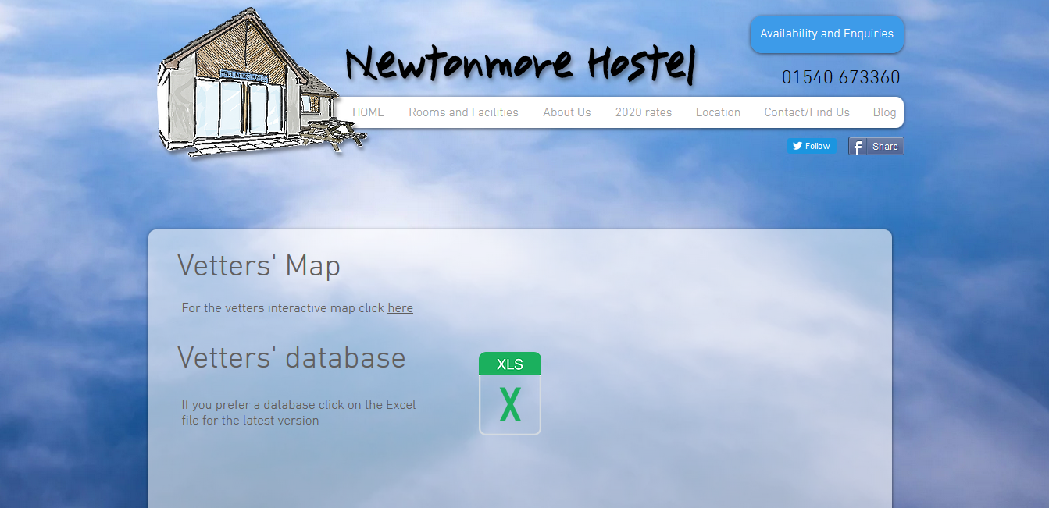

Figure 5: Newtonmore Hostel - Vetters' Database page

File Options

Once at the website, there are 2 options for accessing the Vetters’ Database:
- For the Vetters’ Database interactive map there’s ‘click here’ option. ; and
- for the MS Excel file version there is a ‘XLS’ button, which looks like this:

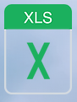
Figure 6: XLS Button
Clicking on word ‘here’ on the Newtonmore Hostel Vetters Map option will open a new tab on your web browser that will contain the latest version of the Vetters’ Database map display.

Clicking on the XLS button will display a message box that provides option to open or save the MS Excel file. The message box will look something like this:

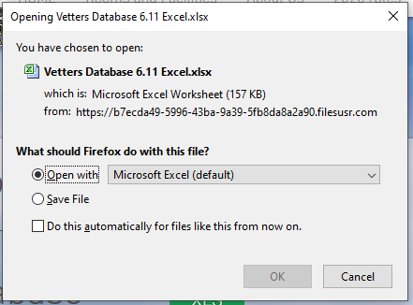

Figure 7: XLS Message Box

To open the MS Excel spreadsheet file click on the OK button, this will open the file in a ‘protected view’. To allow editing of the Excel file click on the ‘Enable Editing’ button, this is at the top of the Excel page and appears thus:

Figure 8: Enable Editing button

To download the file directly to your computer (without opening it) select the ‘Save File’ option on the XLS Message Box (as shown in Figure 7: XLS Message Box) and click on ‘OK’

The Message Box will close and a down-arrow on the message bar (the bar at the top of the screen) will flash as the file is downloaded. Click on this download arrow and a message box something like the following will appear:

Figure 9: Download Arrow and Message

Click on the folder symbol shown in Figure 9: Download Arrow and Message and a new window will open showing the downloaded files:

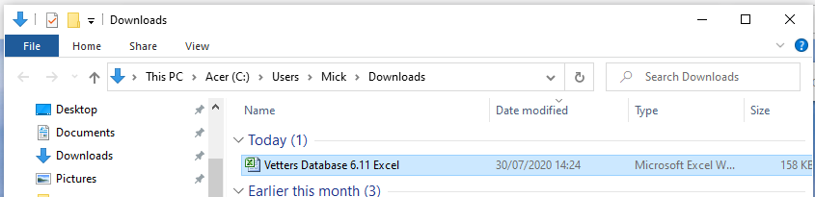
Figure 10: Download File Directory

Using the mouse, grab and move the “filename.xlsx” file (shown here as “Vetters Database 6.11 Excel”) to whichever location (drive, folder or even Desktop) is required. It is suggested that a New Folder be created and named “Vetters Database” in which to store this Excel file. In addition, it is recommended that another folder within the newly created “Vetters Database” folder be created and named “Archive” within which previous (redundant) versions of the database can be kept to hand if required.

Opening, editing and saving the Excel file
The Vetters’ Database Excel file, now it is safely downloaded and stored on the PC, is opened by double-clicking on the downloaded file (or right-clicking on the file and selecting the “open” option).

New Items can now be added into the Excel spreadsheet, which will be used in the next issue of the database.

After editing the file, it is recommended that it is saved with the same filename but with the addition of your initials in order to identify it as your personal, edited copy and to differentiate it from versions edited by other Vetters.

This will avoid confusion between the updated Excel files that are returned to the Coordinators for the new data to be included in the next issue of the database.

Vetters’ Database Map Display
The map will open up on your web browser (Firefox, Edge, Chrome etc.) and will be displayed something like this:

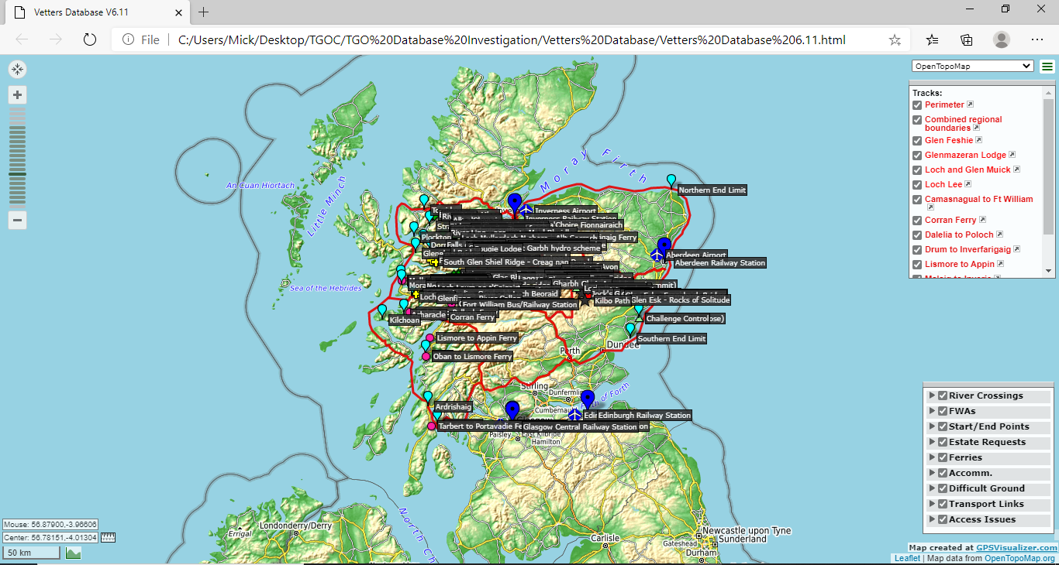
Figure 11: Vetters’ Database Display

The following sections provide the details of the functionality of the Vetters’ Database Map Display as well as those that are part of the Leaflet mapping.

Leaflet Functions
The Leaflet maps are provided with several in-built functions for scaling, dragging, measuring etc. The main ones of interest are described below.

Changing the Map Scale
The map scale (zoom in/out) is in the top left corner and the slider bar is adjusted by clicking either of the +/- buttons as required. A mouse wheel can also be used to zoom.

Figure 12: Scale Slider Bar

Map Scale and Centre Position
On the bottom left of the map, the position of the cursor and the centre of the map is displayed in decimal Latitude/Longitude, below which is a scale bar. To the right of centre position is a ‘measuring tape’ symbol. Click on this tape symbol to plot a line/route (shows the length of the route as well) or plot an area (becomes shaded and shows the measurement of the area).

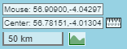
Figure 13: Map Scale and Centre

If the mouse pointer is hovered between the centre coordinates and the measuring tape symbol, the following message appears: “Click here to turn center (sic) on or off”. Clicking places a cross hair symbol () at the centre position of the map display.

Map and Track Selection
On the top right of the display can be seen map selection box (see Figure 14: Map and Track Selection) and the display of the tracks included in the Vetters’ Database (as used for outlining the Challenge Area, Estate Requests etc).

The source of the background map is defaulted to OpenTopoMap when the Vetters’ Database is initially opened. The display can be altered by clicking on the down arrow () and selecting from the options presented. The ones that appear the most useful are:
- OpenTopoMap;
- OSM (TF outdoor);
- OSM (TF Landscape); and
- OpenCycleMap.

The display of the tracks can be toggled (on/off) by checking or unchecking the tick boxes.

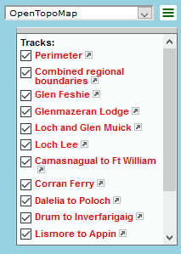
Figure 14: Map and Track Selection
If the mouse is hovered over the small arrow icon to the right of the track title, the hand icon will become a cross icon (+) and the message “zoom to this track” will appear. If the track is currently toggled to the ‘on’ state (i.e. the check box is ticked) and the mouse clicked on this arrow symbol then the map will automatically zoom on that location; however, if the track is toggled to the ‘off’ state (i.e. the check box is empty), any clicking will be ignored.

List (Folder) of Icons by Type and Name
On the bottom right of the display is a box that contains the list of the various icons but grouped by Type (these groups are referred to by GPSVisualizer as Folders): see Figure 15: List (Folder) of icons by Type. When the map is first opened, these data are displayed with the Folder in a ‘collapsed’ state; however, all the icons are displayed on the map.

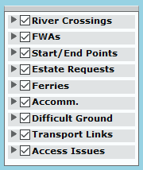
Figure 15: List (Folder) of icons by Type

To display the names of the Items contained within each of the Folders, just click on the right-arrow () icon associated with the Type. The Folder opens to display the names and the right-arrow icon changes to a down arrow () icon. To close the folder, click on the down-arrow and the folder list will collapse.

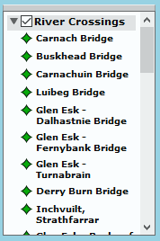
Figure 16: Expanded Folder

By hovering the mouse over a name within a Folder, the related icon on the map has its name highlighted and any associated thumbnail picture displayed. By clicking on a name in a Folder, the related icon on the map has its description box opened, including any associated photograph. If the icon is not within the boundaries of the map scales currently on display, then the map is automatically repositioned to include the selected icon (note: it may be on the very edge of the map display).

Decluttering the Map
When all the icons are on the map display at the same time, the map can become very cluttered. To declutter the map, Folders can be toggled (on/off) from the display by clicking on the Folder tick box.

Moving, Collapsing and Expanding Boxes
Hover the mouse pointer over the bar at the top of a box and a message appears: “drag to move, double click to collapse/expand”. Dragging the box to another place on the screen may be quite useful; however, if the box is collapsed, it reduces to a very thin grey bar that can be quite difficult to pick out – especially if it over the blue of the sea. To expand it back to its normal size, hover and click again – or better still, don’t collapse it anyway.

Panning the Map
To pan the map (move it up/down/left/right), simply ‘grab’ the map with the mouse (the open hand symbol changes to a closed hand) and ’drag’ the map in the required direction. Once the map has been re-positioned, release the mouse button to ‘let go’ (the closed hand symbol reverts to the open hand symbol). The keyboard cursor keys will also pan the map.

Vetters’ Database Icon Meaning
Various icons are displayed, which can be overlaid on the map, and represent the ‘Types’ as defined in Section 5.1. The following table shows the allocation (including colour) of the icons and the spares available:

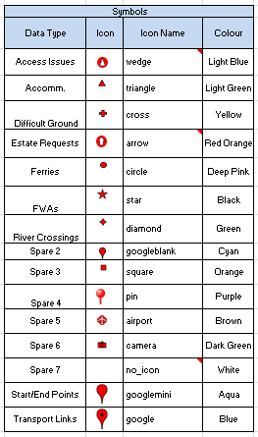
Figure 17: Icon details

Icon Interaction
Each icon has a label displaying the Name associated with the icon. If the mouse is hovered over the icon, the Name label will contrast invert, the thumbnail picture will be displayed (if allocated), and the open hand symbol changes to a pointing finger symbol.

Clicking on an icon causes the description box to appear, which contains the following data:
- OS Map number for the Icon position;
- OS Grid Reference (6-number grid);
- Text information (will vary dependent on the information stored); and
- Date (when the Item was last updated)

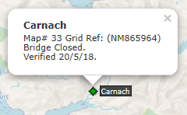
Figure 18: Icon text box
To close the text box, click on the ‘X’ or elsewhere on the map.

Other Function
There are other functions available with the map display that have not been covered in this document. Have a play with the map display and if any other useful functions are discovered that are not addressed in this document, then let the Coordinators know and an update to this document will be done to include them.

APPENDIX B – Building the Vetters’ Database

Introduction
As an overview to the building of the database, this introduction provides a brief description of the applications and files that are used.

The map file is generated using a free, online mapping site called GPSVisualizer (see www.gpsvisualizer.com ). There are several methods of inputting data into GPSVisualizer, which are explained in their on-line tutorials; however, the ones used for the Vetters’ Database are: .gpx files (as generated from mapping software such as Memory-Map) and data taken from a MS Excel spreadsheet file (in a format called a comma separated value (CSV)). In addition to these positional type data, links to pictures can be included within the Vetters’ Database, via the CSV file, if required.

The .gpx files are used to store and present data such as routes and tracks (i.e. lines on a map). The CSV file is used to store and present data about individual points, together with textual information (such as a bridge with its name and current state of repair).

Once the information for the Vetters’ Database map is produced in the required (GPSVisualizer) format, the CSV and .gpx files are loaded into a GPSVisualizer form. A graphical overlay of these data is generated by GPSVisualizer and displayed upon a variety of background maps.

The background map source selected for the Vetters’ database is an open source mapping host called Leaflet, which is similar to Google maps, and provides options for several types of map (road, topo, shaded etc.).

GPSVisualizer also produces an HTML file (containing all the overlay data) that can emailed to others and then used by them to open up the generated map (the Vetters’ Database).

The following sections provide a more detailed description of this process, which should allow others to modify, generate and use the Vetters’ Database map.

Data Collection Formats
As stated above, the 2 main data formats used for the Vetters’ Database are MS Excel and mapping software such as Memory Map (pictures can be also included within the database, but are stored within the spreadsheet as ‘pointers’ to a website location).

The following section describes how they are used to generate the Vetters’ Database.

MS Excel Spreadsheet
A Vetters’ Database spreadsheet has been designed to hold the necessary data in the specific format required by GPSVisualizer to produce the Vetters’ Database. This spreadsheet is controlled by the Coordinator(s). The following subsections describe the data format for the Vetters’ Database. For completeness, a link to information on all the acceptable data types is provided at Section 2.1.2.2; however, it should be noted that GPSVisualizer is a live application and other data format types may be added on the GPSVisualizer website.

The Vetters’ Database has 4 worksheets:
- Data Input;
- GPSV Format;
- Degrees to Dec Converter; and
- Look-Up Tables.

When the (map-based (HTML)) Vetters’ Database file is issued to the Vetters, the spreadsheet (.xlsx) will also be provided.

The following sections describe the contents of each of these worksheets.

Worksheet 1 - Data Input
Worksheet 1 - Data Input, is where the data that the Vetters want to see displayed on the map is entered into the spreadsheet. This worksheet is a text-based database in its own right as it contains almost all of the same data as the map-based output. The spreadsheet is in an easy to read format, with appropriate (and commented) headings, that can have available the usual MS Excel tools used such as search, filter, sort etc. The alternative map-based display for the Vetters’ Database provides the geographic context to the data.

Each spreadsheet column that contains data used in the generation of the map-based display, has its header title contained in a green box. Other information-only cells, which are automatically generated or not required for the map, have their header fields in an orange box. The information held within the worksheet is explained in the following table, which uses the same colour scheme for the Header Title:

Columns with Header Titles annotated with an asterisk and coloured amber in the table below are ‘mandatory’ fields that must be completed for each item; fields that are not annotated with an asterisk may be left blank.

Header Title | Description of Data required (including limitations
Item # | Each data row has an item number pre-filled. This is to use as a quick reference when discussing an item within the database with someone else. This does not appear within the map-based display.
Type* | This defines the type of item (as per Section 5.1) with the following options:  - River Crossings;  - FWAs;  - Start/End Points;  - Access Issues;  - Fence Issues;  - Estate Requests;  - Difficult Ground;  - Ferries;  - Accomm;  - Transport Links; and  - Spares.  The selection is entered using the drop-down menu and includes ‘Spares’ pre-defined for future expansion. The drop-down menu is taken from the Type Definition list in the Look-Up Tables worksheet.  This field is provided so that the spreadsheet users can filter on ‘Types’.
Name* | This is the name of the Item in question, e.g. Carnach, Lairig Ghru, Glen Feshie. As the ‘Type’ field is not included textually in the map-based display (it dictates which symbol is used on the map) , it could be included within the ‘Name’ field if required and will be displayed on the map as the title, e.g. ‘Carnach Bridge’ instead of just ‘Carnach’.
First Text Line | This is the first of several text fields, which can contain additional, relevant data such as contact details, e.g. hotel or person’s name, address, phone no etc.
Other Free Text Fields | Another 5 text fields are available to be used to collect whatever additional text, for the item in question, that the Vetters want to record. The text will then appear in the 'pop-up' box on the map-based display when the icon is clicked.
OS Map Number(s) | As it says, it is the OS Map number (or numbers) for the item being entered. If there is more than one map number, then enter both numbers.
UK OS Grid Position* | This the OS UK Grid position in the format LLnnnnnn (where L=letter and n=number) e.g. NM865964. The format required is for a 6 digit reference.
Alt | This is the altitude in metres of the item being entered, if required for display.
Status* | This contains the verification status (accuracy of information) of the information for this Item and is entered via the drop-down menu. It currently has 2 options:  - Reported: where the status has been reported from one source only;  - Verified: where the status has been confirmed via a second source; and  - Info Required: when the further information is needed.
Date* | This is the date associated with the latest update of the item in question.
Figure 19: Data Input Header Fields

Worksheet 2 - GPSV Format
This worksheet contains the data formats, descriptors and keywords required by GPSVisualizer to generate the map-based display. It is essentially the same data as entered into Worksheet 1 – Data Input (see section 2.1.1) and is mostly copied automatically for worksheet 1. In this Worksheet 2, some of the text fields from worksheet 1 have been collated, via an automated formula, into a single cell to form a single string of characters to ensure that the text is handled correctly by GPSVisualizer.

The only data fields that need to be entered into Worksheet 2 – GPSV Format, which are not copied automatically from Worksheet 1, are the position of the item (in Decimal Lat and Long); and those dealing with any associated pictures (see Appendix B, section 2.3).

Thumbnails and Photographs
Further data fields are contained within this worksheet to include additional GPSVisualizer functions such as those dealing with thumbnail pictures and photographs.

The web address for the selected picture is entered into the relevant cell. The ‘thumbnail width’ or ‘photo-size’ scales the size of the picture as it appears on the map (see Appendix B, section 2.3).

Other (un-used) GPSVisualizer Fields
There are many more field options provided by GPSVisualizer that are not currently used by the Vetters’ Database, which may be of use in future iterations. These can be found at https://www.gpsvisualizer.com/tutorials/waypoints.html.

Worksheet 3 - Degrees to Dec Converter
GPSVisualizer requires the Latitude and Longitude position of an Item to be in a decimal degrees format (not degrees, minutes and seconds format). This worksheet provides a simple converter from degrees, mins and seconds to decimal degrees as follows:

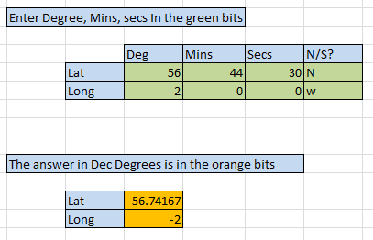

Figure 20: Degrees to Dec Converter
The operation is fairly self-explanatory: enter the data in the green boxes (including N, S, E or W) and the answer in Decimal Degrees is displayed in the orange boxes. Note that the negative signs in the Dec Degrees are important– they denote the hemisphere.

Worksheet 4 - Look-Up Tables
Worksheet 4 contains the Excel lookup tables that are used by the other worksheets to prevent invalid data being entered into a cell. ‘Spares’ have been included to make additions to the lists simpler – just overwrite the ‘Spare’ field with the new title. It is not the intention of this document to explain MS Excel Data Validation.

Symbols: Appearance, Names and Allocation
The symbols available within GPSVisualizer, together with their names, colours and Type allocation are contained in Figure 21: Worksheet 4 - Symbols Table. The choice of symbol and associated colour is made in Worksheet 1 – Data Type.

Figure 21: Worksheet 4 - Symbols Table

It should be noted that the colour is pre-set based upon the Type selected; however, if a different colour is required then this is achieved simply by overwriting the one shown in the Color (sic) column of the GPSV Format worksheet for the Item in question (using the dropdown menu option).

GPSVisualizer Colours
There is a huge range of colours available within GPSVisualizer; however, within the Vetters’ Database only the following colours have been made available. The initial choice of colour for a symbol is made dictated by Type selected in in Worksheet 1 – Data Type.

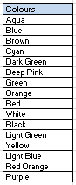
Figure 22: Colour Options

GPX Files
GPSVisualizer also accepts a .gpx format of data, which is input merely uploading the .gpx filename in the GPSVisualizer Form (see Figure 25: GPSV Leaflet Form): see section 3.4 for details. This will draw a line on the map.

The .gpx data files produced by Anquet/Memory Map will be as a route (a series of waypoints joined together) or as a track (just a line on a map that doesn’t show the waypoints).

GPSVisualizer accepts both of these types of .gpx files; however, in order to reduce display clutter it is best to select the option ‘Convert to tracks’ option for the ‘GPXCSV Routepoints’ setting in the GPSVisualizer form. This will produce a line-only display on the map without all the individual waypoints being shown that were used to make up the route. This action is covered in detail in Section 3.3.

Picture Files
In addition to the .gpx files and .xlsx files, another useful GPSVisualizer function is that of displaying pictures (held as a .jpg file) on the maps. They are linked to an Item within the spreadsheet, as one of the spreadsheet fields, by the inclusion of a ‘pointer’ to the location of the picture on the internet. Note: the picture itself is not stored in the spreadsheet, just a link to it.

This ‘pointer’ is called a Uniform Resource Locator (URL) and appears in a format something like this: https://www.tgomagazine.co.uk/wp-content/uploads/sites/2/2019/04/Leading-Lines-testing-conditions-Kaha-01-4548SMALL-820x547.jpg. This is obviously long and unwieldy, so an interim step is taken to reduce the length of the URL address via some free, online software to produce a shorter URL. In this instance, using this URL reduction software, the long 127-character URL above is reduced to https://tinyurl.com/ycbge4x7, which is only 28 characters long. Essentially, this website produces a ‘pointer’ to the ‘pointer’. The website used for the Vetters’ Database is called TinyURL and can be found at https://tinyurl.com. It is easy and self-explanatory to use.

Thumbnail Pictures
If the URL is stored in the spreadsheet as a ‘Thumbnail’ (a GPSVisualizer keyword), it then appears as a small picture when the mouse is hovered over a map symbol and includes the Name associated with the symbol.

Photographs
When the User points and clicks on the symbol, a larger dialogue box opens that contains other, pertinent information associated with the symbol (i.e. Name, Map Number, OS Grid position and Description data). If the URL has been stored in the spreadsheet as a ‘Picture’ (another GPSVisualizer keyword) then the dialogue box will also contain the picture (larger than the thumbnail).

Acquiring the picture URL
Acquiring a picture URL is reasonably straightforward:
- find a picture on the internet;
- right click; and
- select ‘Copy Image Location’.

That’s it, the long URL is now copied to the clipboard and is now available to paste elsewhere; however, there may be some difficulties in using or sharing it due to privacy issues/access rights with the photo.

In addition, to be consistently available, the pictures to be used within the Vetters’ Database must be stored in a location on the internet that is a) publicly available (or at least where all the Vetters have been given access rights) and b) permanently available. If the internet site owner removes the pictures then the link is broken and the picture will no longer be available for display (a broken link symbol will be displayed in its place).

As the Vetters’ Database is for the purposes of the TGOC, it is recommended that the Newtonmore Hostel is used as the host site for the pictures for the Vetters’ Database, which is under the control of the Coordinators.

Storing the URL(s) in the Spreadsheet
Any pictures that are intended for display as a thumbnail or photograph need to have their URLs stored directly into the GPSV Format worksheet of the Vetters’ Database Excel spreadsheet. Each can have a ‘size’ assigned to modify their respective height and width, as shown in the figure below:

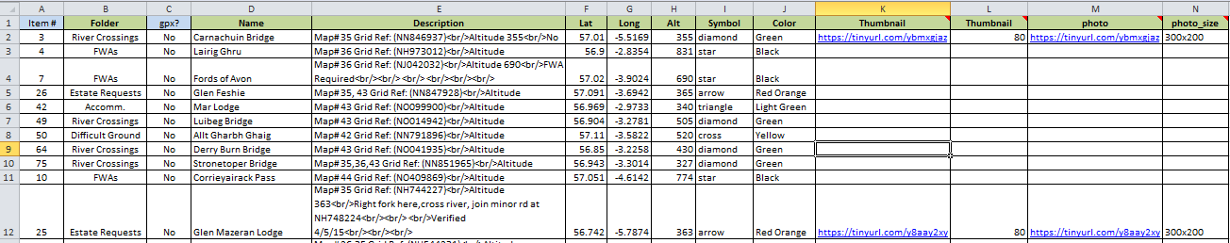
Figure 23: Vetters’ Database GPSV Format

GPS Visualizer Data Input
This section describes how the aforementioned CSV and .gpx formats are entered into the GPSVisualizer for subsequent display as a map. Once again, this is not overly complex – all the leg work has already been completed.

The GPSVisualizer Input Form that uses the Leaflet mapping can be found at the following location: https://www.gpsvisualizer.com and clicking on the Leaflet icon from the options as shown in Figure 24: GPSV Format Options:

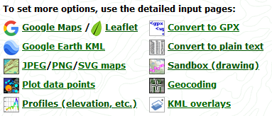

Figure 24: GPSV Format Options
Which then appears thus:
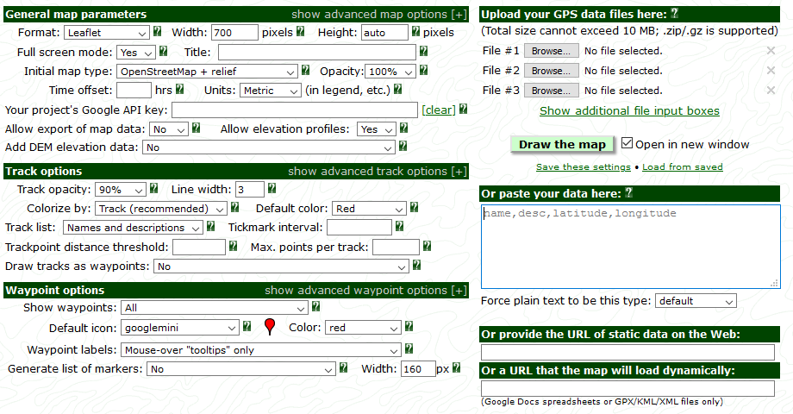
Figure 25: GPSV Leaflet Form
As can be seen, it has seven data blocks (the dark green header boxes):
- General map parameters;
- Track options;
- Waypoint options
- Upload your GPS data files here:?;
- Or paste your data here:?;
- Or provide the URL of static data on the web:; and
- Or a URL that the map will hold dynamically.

Only the first five of these are used by the Vetters’ Database so the following sections only provide details on the ones used.

General Map parameters
Within the ‘General map parameters’ box, as shown below in Figure 26: General Map parameters, click on the ‘+’ symbol in the top right of the display to expand the options box.
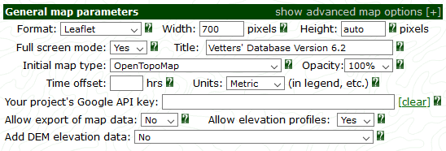
Figure 26: General Map parameters

The expanded display is shown in Figure 27: General map parameters – expanded below.

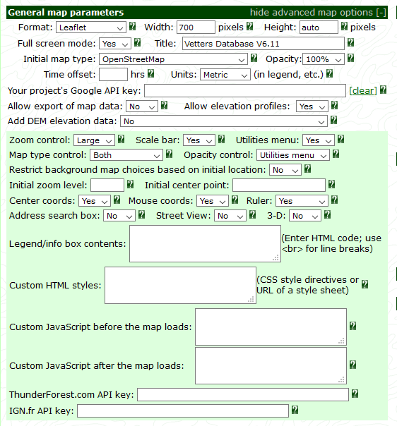

Figure 27: General map parameters – expanded

Most of the settings to the General map parameters will appear pre-set; however, the following settings (highlighted in red in Figure 27: General map parameters – expanded) will need to be made:
- The Title needs to be entered (e.g. ‘TGO Vetters Database Vsn xx’);
- The “Initial map type” set to ‘OpenTopoMap’; and
- Center coords, Mouse coords and Ruler all set to ‘Yes’.

Note: the “Title” will then appear as the name of the browser tab when the database is opened.

Track Options
The Track options data block is where the settings for how GPSVisualizer deals with the .gpx tracks (or line) data. Within the ‘Track options’ box, as shown below in Figure 28: Track options, click on the ‘+’ symbol in the top right of the display to expand the options box.

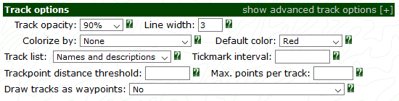
Figure 28: Track options

The expanded display is shown below in Figure 29: Track Options – expanded.

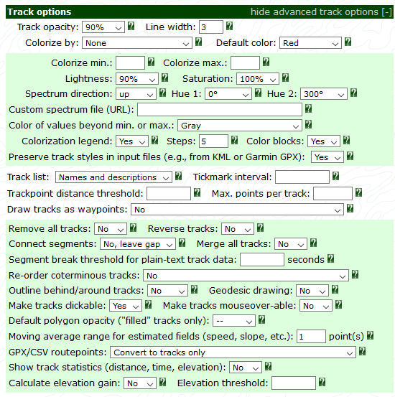

Figure 29: Track Options – expanded

The default settings are used other than those highlighted in red:
- “Colorize by:” is set to ‘None’;
- “Track List” is set to: ‘Names and descriptions’; and
- “GPX/CSV routepoints” is set to ‘Convert to tracks only’.

Waypoint Options
This data block deals with the displays associated with the waypoints entered from the MS Excel CSV file, and appears like this:
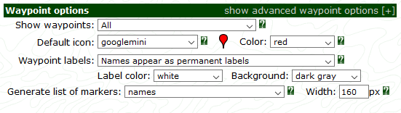
Figure 30: Waypoint options
To access all of the required settings, the ‘Waypoint options’ data block need to be expanded, which is achieved by clicking on the [+] symbol in the top right corner of the block. The block will expand to look like this:
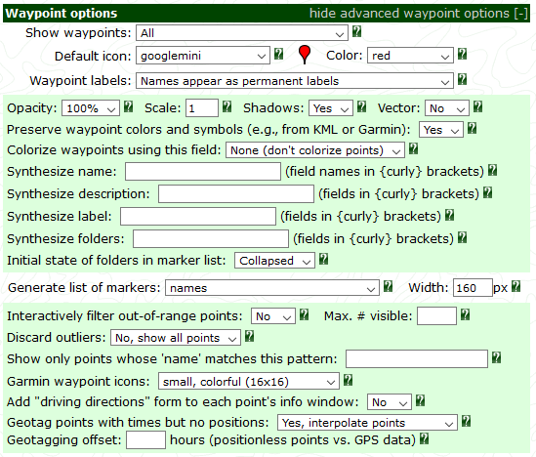

Figure 31: Expanded 'Waypoint options'
The following 2 options (as highlighted in red) should be selected via the down arrows the ends of the boxes:
- “Initial state of folders in marker list” set to: ‘Collapsed’; and
- “Generate list of markers” set to: ‘names’.

These options add a table of the waypoint folders to the map, and set the initial state of these folders to ‘Collapsed’ (see Figure 15: List (Folder) of icons by Type).

Upload your GPS data files here:?
This data block deals with the upload of a stored .gpx file into GPSVisualizer for display on the map:
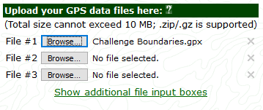
Figure 32: GPS data files upload

This is a simple process to follow:
- Click on ‘Browse’ option of a File #;
- A File Upload window is opened;
- Locate where the required .gpx file is stored and click on it;
- Click on OK;
- The File Upload window closes; and
- The .gpx file is uploaded with its filename now displayed.

The default display allows up to 3 GPS files to be loaded; however, if the ”Show additional file input boxes” line is clicked, this is increased to 8 GPS File numbers.

Or paste your data here:?
This data block deals with the upload of the MS Excel CSV file into GPSVisualizer for display on the map. The data block appears thus:
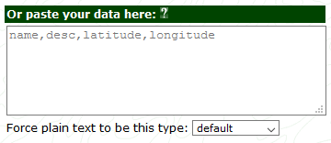
Figure 33: CSV Data Input

The data that needs to be pasted into the above box is the CSV data taken from the MS Excel spreadsheet. As the spreadsheet has been already formatted in line with the GPSVisualizer requirements then the actual process is fairly straightforward:
- with the ‘Worksheet 2- GPSV Format’ on view, Save the completed MS Excel spreadsheet as a CSV file;
- Open MS Word, select Open and select (click on) the saved Excel CSV file;
- Copy all the lines of data presented in the word document (this may run into multiple pages); and
- Paste this into the CSV Data Input box (as shown in Figure 33: CSV Data Input) Note: ensure that all existing data in the Data input box has been deleted (if there is any).

The following sections provide more detail on the above sequence.

Saving a spreadsheet as a CSV file ready for use
To save the spreadsheet ready for use with the GPSVisualizer:
- Open the spreadsheet (the .xlsx format);
- Select the ‘GPSV Format’ tab;
- Select ‘File’ , ‘Save as’ option;
- In the ‘Save as type’ box, click on the down arrow and select ‘CSV (Comma delimited)’ option (note: there are several other CSV options presented in the list);
- Click on ‘Save’; and
- Close Excel.

The spreadsheet is now saved as a CSV file.

Opening a CSV file in MS Word
Open up MS Word, select Open, and click on the saved Excel CSV file. A dialogue box as below may open if the Excel file is still in open:

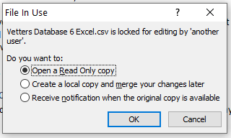
Figure 34: File In Use
If it does, select the ’Open in Read Only copy’ and press OK. The resulting Word document will now look something like this:

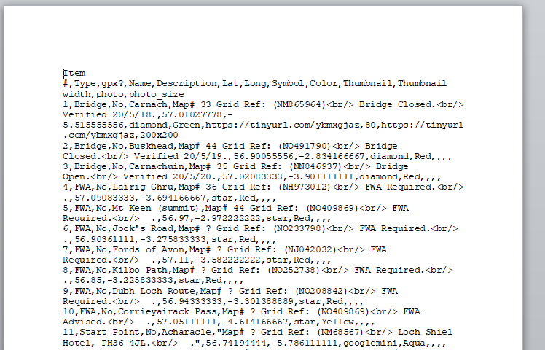

Figure 35: CSV File in Word

Copying the CSV data
To copy the data simply:
- click anywhere within the document;
- select All the document text (by pressing CTRL A); and
- Copy all the document text (by pressing CTRL C).

Pasting the CSV data into the GPSVisualizer From
Click inside the GPSVisualizer box entitled ‘Or Paste you data here:?’ and paste the copied data into it by pressing CTRL V. The box should now look something like this:
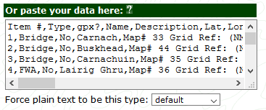
Figure 36: Completed CSV Data Box

Saving and Loading GPSV Settings
Instead of having to manually select all the setting each time a map is to be drawn, it is possible to save the current settings for use later. The following sub-sections provide the details on how this is carried out from within the GPSVisualizer Form (the options are just below the Draw the map box.
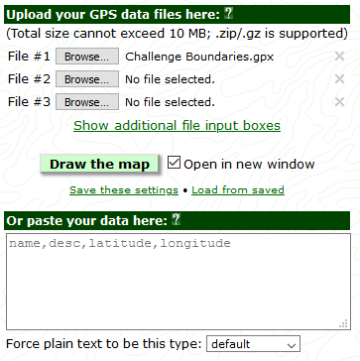
Figure 37: Saving and Loading Settings

Saving the Settings for the GPSV Input Form
First of all, make all the settings that are required to the various data boxes and then click on
“Save these setting” as shown in Figure 37: Saving and Loading Settings. A dialogue box opens stating that the settings have been saved as a cookie together with some further information on saving settings. Click on the OK box to clear the message. The settings have been saved.

Loading the pre-saved Settings into the GPSV Form
To load the pre-saved setting just click on “Load from saved” as shown in Figure 37: Saving and Loading Settings and the current form will be updated with the saved settings.

Generating and sharing the map
This section describes the process for generating the map using the methods as described in Section 3 and producing the HTML link to send to other users.

Build Preparation
In preparation for generating the map, the following items should be available on the computer:
- The web browser should be open;
- The MS Excel Vetters’ Database should be open; and
- The required .gpx files should be available on the computer.

Generating the Map
The sequence to generate the map is:
- Got to the GPSVisualizer website (https://www.gpsvisualizer.com) and click on the ‘Leaflet’ option;
- Set the GPSVisualizer options as described in:
  - General Map parameters (see Appendix B, section 3.1);
  - Track options (see Appendix B, section 3.2); and
  - Waypoint options (see Appendix B, section 3.3).
- Upload the .gpx files that are required for display (see Appendix B, section 3.4); and
- Upload the CSV data that are required for display (see Appendix B, section 3.5).

The GPSVisualizer has now been loaded with the CSV and .gps files. All that needs to be done is to generate the map. This is achieved by clicking on the green ‘Draw the map’ button, shown below between the ‘Upload your GPS data files here:’ and the ‘Or Paste your data here:‘ boxes.

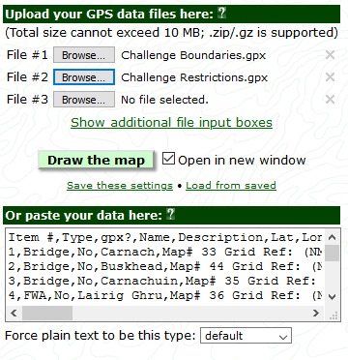
Figure 38: Generating the map

The map will open in a new tab and look something like this:

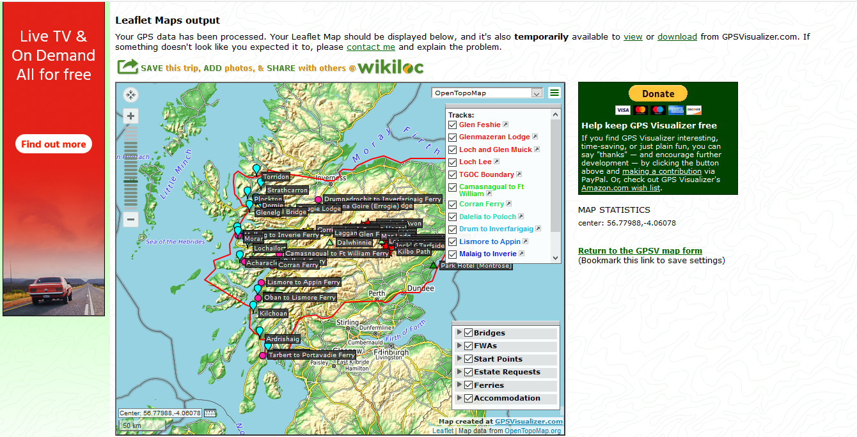
Figure 39: Leaflet Map output

View/Download Options
There are 2 options highlighted in green on the top sentence of this page: ‘View’ and ‘Download’. The following sections describe what these options provide.

View
Selecting the ‘View’ option replaces the display shown in Figure 39: Leaflet Map output with a full-screen functioning map.

Download
Selecting the Download option opens a dialogue box as shown below:

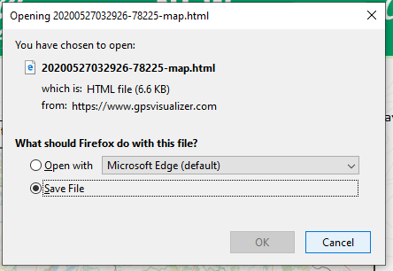
Figure 40: Download Dialogue Box

This allows the user to open the map via the html link or to save the link. This is the link that needs to be emailed to the users. First of all, select the Save File option and click on OK, which will download the HTML (map) file. Then follow the process as defined in Section 1.11.1 to download the file to the local storage. As the filename provided is fairly meaningless, once the file is stored in the appropriate location, it should be re-named to make it more meaningful, e.g. Vetters Database Version 5.

…And that’s it. Simples…

APPENDIX C – New Type/Item Data Required

Introduction
This Appendix details what information is required to set up either a new Type or a new item within an existing type.

New Type
For a new Type (e.g. River Crossings) the only requirement is to agree on what title to call it. This name needs to be added into the ‘Type Definition’ in the Vetters’ Database ‘Look-Up Tables’ worksheet so that it will appear as an option in the drop-down menu ‘Data Input’ worksheet.

New Item
For a new item, the information required is detailed in Figure 41: Item Data required below. Those items that are mandatory (needed either to be meaningful or to allow GPSVisualizer to work) are highlighted in Amber; those that are optional are highlighted in Green and can be left blank (although all that will appear is a named, coloured icon at a position on a map). These data items should be added to your copy of the Vetters’ Database Excel spreadsheet and coloured as red text to make it easily identifiable; or just send the data in an email to the Coordinators.

Title | Description of Data required (including limitations
Type | This defines the type of item e.g. bridge, start point etc.
Name | This is the name of the item in question, e.g. Carnach, Lairig Ghru, Glen Feshie.
Contact Details | This field contains the Contact details, e.g. Hotel or person’s name, address, phone no etc.
Free Text Fields | These fields are used to add whatever additional text for the item in question the Vetters want to appear in the 'pop-up' box on the map-based display when the icon is clicked. They are essentially free text areas. Each text field will appear as a separate line in the ‘pop-up box’ on the map when an icon is clicked.
OS Map Number(s) | This is the OS Map number for the item being entered. If there is more than one map number, then enter both numbers. If not known leave blank.
UK Grid Position | This the OS UK Grid position as a 6 number reference.
Alt | This is the altitude in metres of the item being entered, if required for display.
Status | This contains the verification status (accuracy of information) of the information i.e. reported or verified.
Date | This is the date associated with the last update of the item in question.
Figure 41: Item Data required

